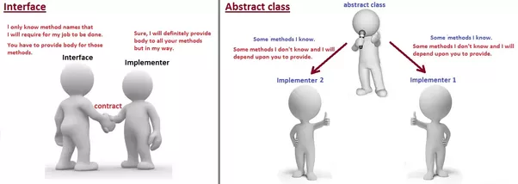

Interface:- “I only know methods names that I will require my job to be done. You have to provide body for these methods.”
Implementors:- “Sure , we’ll provide body to all your methods but in our own way.”
That’s the contract.

Abstract class:- “ some methods I know. I’ve implemented them. Some I don’t know, I want you to provide implementation to them.”
Implementors:- “Sure , we’ll provide body to those methods but in our own way.”
That’ the combination of contract+implementation.

